{{Project Name}}

Group Name:

# Project Code Link

Share the link to the project code (github/onedrive). Ensure that the code is shared with Ashrafur.rahaman@cestarcollege.com

# Project Details

Write a few lines of details about the business problem you are trying to implement or solve.

# Team Members:

|  |  |
| --- | --- |
| Student ID | Student Name |
|  |  |
|  |  |
|  |  |

# Your sitemap

Create a sitemap that shows the pages and the parent-child relationship of the pages. Here is an example sitemap.

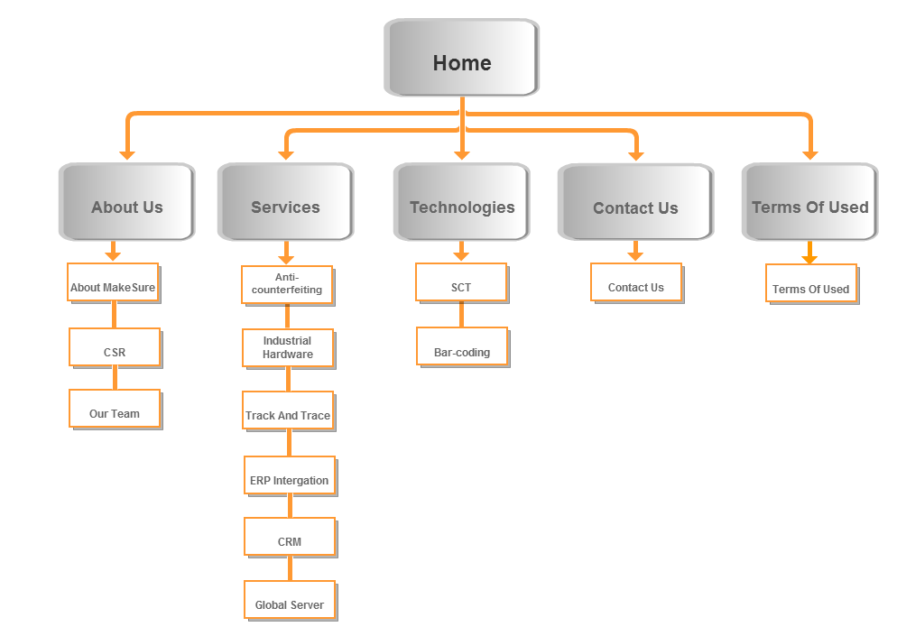

# Page and Feature List

|  |  |  |
| --- | --- | --- |
| **Page Name** | **JavaScript and jQuery Functionalities available on the page** | **Team members worked on it** |
|  |  |  |
|  |  |  |
|  |  |  |
|  |  |  |
|  |  |  |
|  |  |  |
|  |  |  |

# Pages screenshot with details

In this section, you need to add screenshots of each page of your project and also details about the functionalities of the page. You do not need to add screenshots of the code.

|  |  |
| --- | --- |
| Page Name & created by: |  |
| Functionalities are available on the page: |  |
| Screenshot of the page: |  |

|  |  |
| --- | --- |
| Page Name & created by: |  |
| Functionalities are available on the page: |  |
| Screenshot of the page: |  |

|  |  |
| --- | --- |
| Page Name & created by: |  |
| Functionalities are available on the page: |  |
| Screenshot of the page: |  |

|  |  |
| --- | --- |
| Page Name & created by: |  |
| Functionalities are available on the page: |  |
| Screenshot of the page: |  |